SUMMER SESSION 2013 in EUROPE
Hist. 360/Pol. Sci. 499

EVOLUTION OF EUROPEAN GOVERNMENT AND SOCIETY

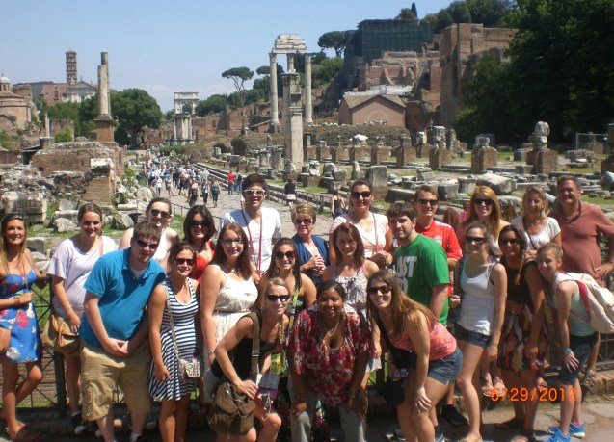

The Course

This 6 credit hour study abroad course includes travel to Italy, Belgium, the Netherlands, Greece, Spain and Turkey

The program will employ hands-on learning to provide students with an experiential understanding of the history of early political thought and political systems. This is not your typical study abroad course where students go to a foreign country and take classes at a host university. It is a holistic approach that maximizes the international experience.

The holistic experience means students should get an appreciation of not only the history of European political systems, but gain an understanding of European society and culture both past and present. To achieve this end, we will not only focus on historical trends of various states, but also compare these with contemporary issues. In addition we will consider changes in culture and society as depicted in the art and architectural treasures of Europe.

The course will focus on how political structures and political theory have evolved. We will begin with an exploration of early civilizations (Minoan, Greek, Roman) and then progress to the medieval and early modern European states. It will conclude with an examination of the evolving structures of the European Union and the security arrangements under NATO. Special emphasis will be placed on providing a better understanding of contemporary political/societal structures and thought.

Course objectives

- To provide students with an understanding of the evolution of political systems from Ancient Greece to the European Union.
- To provide students with a better understanding and appreciation of the value of history and culture.
- To enhance and sharpen analytical abilities and communication skills. To make students think and re-examine their own goals, aspirations and values.
- To create an insatiable appetite for knowledge.

The Instructors

Professors Dr. Sally Brasher and Dr. Niel Brasher will conduct the program. Sally is an Associate Professor in the Department of History at Shepherd University. Sally has done extensive research in Italy and teaches courses on European history. She has published a book and presented numerous papers on the history of many of the places we will be visiting. Niel is a Professor in the Department of Political Science at Shippensburg University. He spent two years running American University's highly successful study abroad program in Brussels and offers courses in International Politics. The Brashers have led over twelve different university groups to Europe.

Orientation /Online Work

Before departing we will administer an intensive set of online orientation classes. This will include a survey of European history from the Roman Empire to the present, including an introduction to the various political systems and an overview of what to expect from an international experience. In addition, current trends and various cultures will be examined in order to understand the current context and the culture of the places we will be visiting. Students will obtain a basic knowledge of political economy and the international governmental organizations crucial to trade and security. An emphasis will be placed on examining the many current controversies in these areas.

This is a six credit-hour experience; thus, the online component will have examinations, paper assignments, readings and other exercises.

Tentative Schedule

May 20 – June 13

May 20 Depart for Europe

We will most fly out of a Washington, Baltimore or Philadelphia airport. Students will be responsible for getting to and from the airport.

Belgium

Week 1 — Brussels

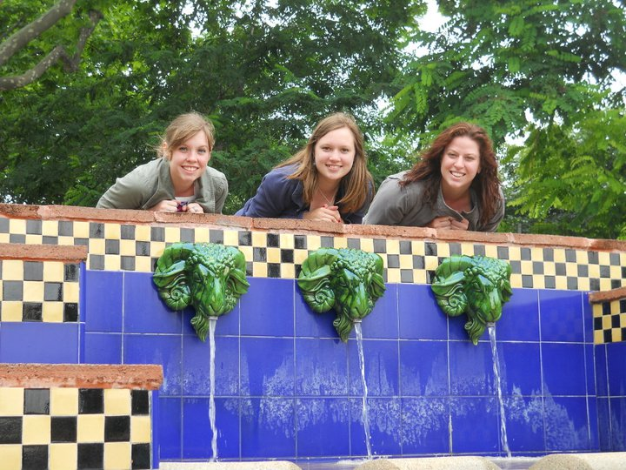
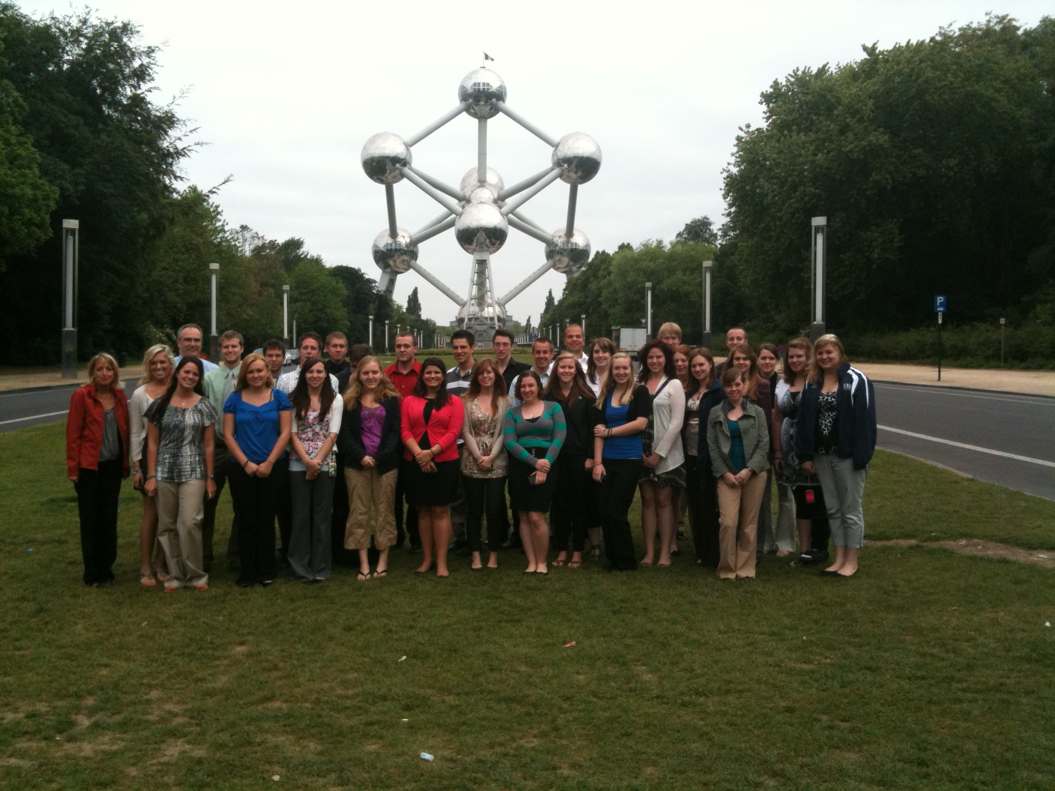
Modern Belgium encompasses an area that has been claimed by all the major powers of Europe. During the Renaissance its cities, including Brussels, were part of an international commercial center and felt the influence of the great Italian, Dutch and English Renaissance merchants, thinkers and artists. Brussels is also conveniently located within a three-hour train ride to Paris, Amsterdam, and many other destinations in France, Germany, Holland, and Belgium.

While in Brussels students will be staying with host families. These host families will all be situated around the northern suburb of Brussels in two small towns, Alsenburg and St. Genesis-Rhode.

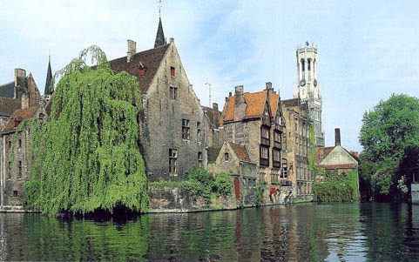
The focus of the course in Brussels is to gain knowledge through meeting with decision-makers and visiting sites. Examples of what we will be doing:

- Taking a city tour of Brussels highlighting the political and historical developments of the famous Grand Place and tracing Belgium's role in European history overall.
- Visiting the beautiful medieval town of Bruges.
- Several guest lecturers will discuss Belgian history and its role in modern Europe.
- We will also study the state of modern European integration with visits to NATO and SHAPE headquarters, including a meeting with NATO officers.
- Visiting to the former WWII concentration camp of Brendonk.

Amsterdam/The Hague

We will travel to the historic port city of Amsterdam. Students will be free to wander in one of Amsterdam’s famous museums (Van Gogh Musuem, Rijksmuseum, Anne Frank Haus ) and or see the numerous canals of the city. We will stay in The Hague, the center of international law and jurisprudence. Our itinerary will include a briefing at the International Criminal Court and a tour of the Peace Palace, which houses the International Court of Justice. We may have the opportunity to sit in on one of the trials.

Spain/Italy

Week 2 - Barcelona, Florence, Siena, Rome

In Barcelona we will consider the political and social implications of the divide between the Spanish and Catalonian cultures. In addition we will explore the fascinating architectural treasures of Barcelona from the original Roman walls encompassing the old medieval city to the early 20th century modernist movement architecture of Gaudi, in order to view the overlapping styles and their contributions to the city over the centuries. A favorite activity is walking down the famous Rambla avenue before heading over the the chic beaches for sun and swimming, volleyball or people watching at one of the many seaside cafes.

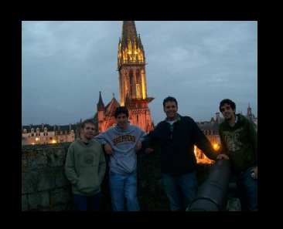Italy

Siena/Florence

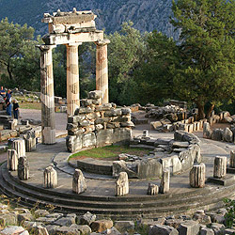

Siena is a college town that, apart from having a beautiful and active city center called the Campo, contains numerous interesting treasures. We will discuss the various governmental structures of these Renaissance city states and enjoy their historical treasures. In addition, we will use Siena as a launching pad for a day trip to Florence. Students will be given a tour of the Uffizi Gallery, which houses the major art treasures of the Renaissance. In addition they will be given tours of several palaces and churches in the city.

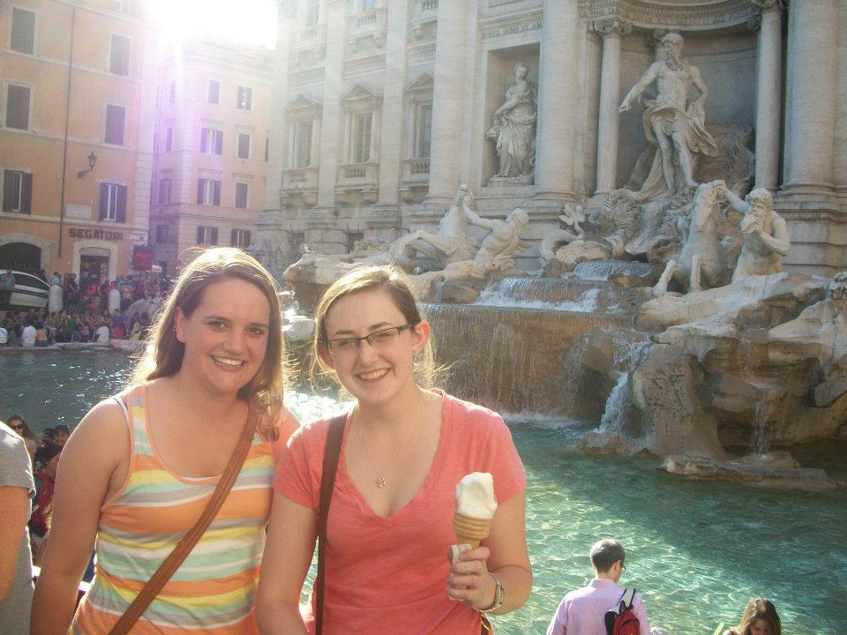
Rome

We will spend three days in Rome. As Ancient Rome has been the model for many of our western institutions of government, society, and culture, it is a great place to start in order to understand the heritage of European institutions. While in Rome, we will visit the site of the ancient Forum, Coliseum and other famous ruins. We’ll also tour the Vatican Museum to see the treasures housed there, as well as develop an understanding of the role of the Church in European history.
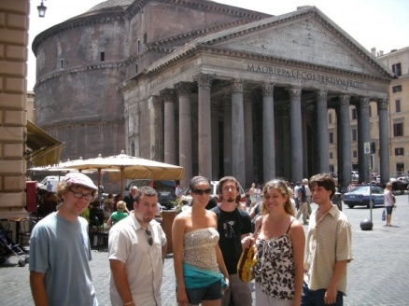

Week 3 — Greece and Turkey

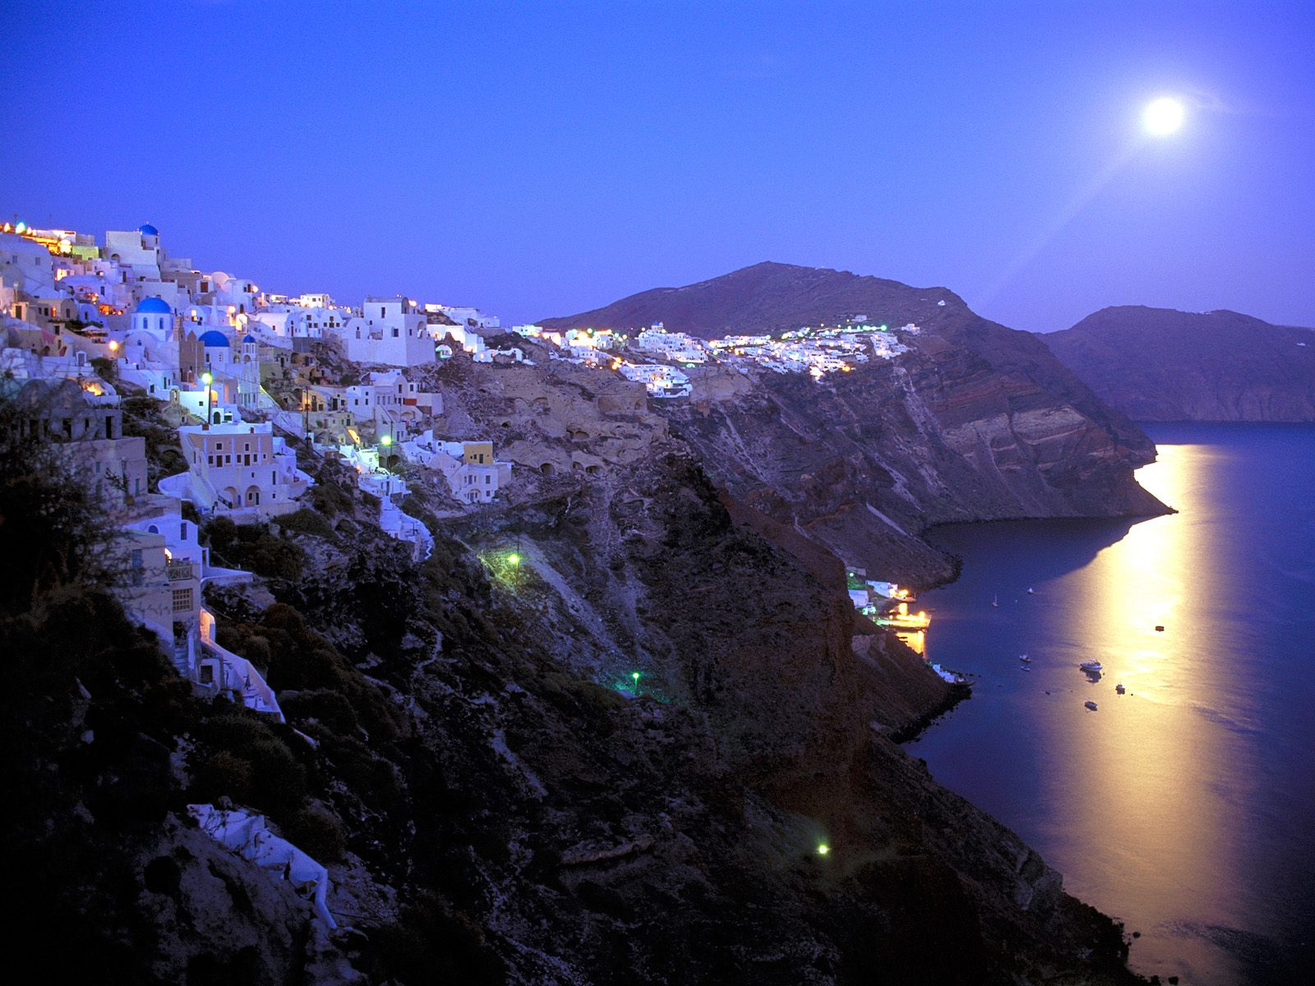
Greece

Athens free time in Greek Islands

You will be given three days to do whatever you want. Realistically your options are to stay in Santorini; Naxos (known for its interesting landscapes and hiking); Ios (known for its long sandy beaches and nightlife); Or Mykons (gathering place for the rich and famous); You cannot go wrong with any of these choices. In mid June, lodging tends to be reasonably priced and abundant.

Athens

We will arrive in Athens and stay two nights. Athens is the birth place of western civilization and we will visit the Acropolis and Forum and discuss the contributions made by the classical Athenians to politics and cultures. We will also have a chance to visit the famous Plakia neighborhood with its medieval streets and busy modern nightlife.

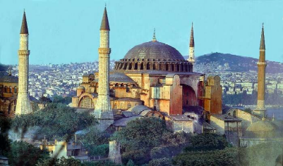
Istanbul

Istanbul has been at the crossroads of many civilizations, old and new. Apart from being the only major city to straddle two continents, it has been the capital of the Roman, Byzantine and Ottoman empires. In the Cold War it was the southern flank of the NATO alliance. In the War on Terrorism it is the lynchpin between East and West. Turkey borders numerous countries (many unstable) including Iraq, Syria, Iran, Armenia, Greece and Georgia. It is an Islamic country with a secular governmental structure. In Istanbul we will discuss historical and contemporary issues and visit such sites as the Grand Bazaar, Blue Mosque, Hagia Sophia, Topkapi Palace.

Academics

The classes are one three credit hour course in European history and one three credit hour course in Political Science titled The Evolution of European Government and Society. Students will complete intensive online work before departure and more online work after the program has been completed. This will include readings, papers and examinations. While in Europe students will be required to keep an academic journal, where they react to tours, sites, readings and culture. Some of their reactions will be directed through questions from the instructor.

Program Costs

Program costs (includes: airfare, lodging, field trips, entrance fees, activities, some meals, transportation in Europe) are $3599 per student. In addition, students will need to pay tuition for the six credit hours. Students taking six credits or more in the summer are eligible for financial aid loans — including program costs. Students must secure their own passports.

Eligibility and Rules

Typically we recruit students from a variety of backgrounds. While there are many political science/history students, they normally make up only half the trip membership. There are no academic pre-requisites for this trip. We look for people who are in good academic standing (i.e.. no where near probation) and have a good attitude. We are looking for students who interact well with others and have an open mind toward learning. We can and will teach you everything else. Students learn a great deal about politics, history and economics, but they report learning much more about cultures and themselves.

We find this type of program attracts a wide variety of interesting people who self-select themselves by their eagerness to take the risk to go on such a trip. Historically we have had almost 100 percent satisfaction rates. Most report it is the most valuable learning experience they have had in college.

We are teachers and facilitators, not chaperones. Students are treated like the adults they are. The few rules we have consist mostly of the need to treat others (locals, tour guides, bus drivers, colleagues) with respect; attend all sessions (everybody always does); be attentive at all sessions; no drugs and no excessive drinking. Students who violate the rules will be dismissed from the program and must make their own way home.

We will use a variety of forms of transportations. Students will be responsible for carrying their own luggage and keeping track of their personal belongings.

Application

A $350 non-refundable deposit* is required with your application. Applications will be taken until the program is filled. Make your check out to Shippensburg University/Brussels Study Abroad. The program is limited to 20 students. Airfare ( aprox. $900) will be due December 15, 2011. The balance will be due May 1. Please apply as early as possible. For application information contact Dr. Brasher at Sbrasher@Shepherd.edu.

Note: The deposit is refundable if the program is filled or you are not accepted for the trip. The deposit is not refundable if you fail out or drop out of school.

Additional Information
If you have any questions, please contact:

Prof. Sally Brasher

Department of History

White Hall 326

(304) 876-5253

Sbrasher@shepherd.edu

“I never thought in a million years I would make it to Europe. I come from a rural background and I was the first in my family to see what was across the Atlantic Ocean. I would not trade the three weeks I spent on this trip for anything in the world. I learned not only the fundamentals of European government, but also about myself and how I can adjust to many different situations. I feel like I can accomplish anything!”

Jessie Sigley

